My Iowa State University dissertation and thesis title page: A beta sample

by

Cy Cardinal

A thesis submitted to the graduate faculty
in partial fulfillment of the requirements for the degree of
MASTER OF ARTS [choose MASTER OF SCIENCE, ETC]

Major: History [choose your major]

Program of Study Committee:
Nomen Nescio, Major Professor
Jane Doe
Zhang San

The student author, whose presentation of the scholarship herein was approved by the program of study committee, is solely responsible for the content of this thesis. The Graduate College will ensure this thesis is globally accessible and will not permit alterations after a degree is conferred.

Iowa State University
Ames, Iowa
2023 [choose your graduation year]

Copyright © Cy Cardinal, 2023. All rights reserved.
DEDICATION
The Dedication page is optional and follows the Title Page. The Dedication and Title Page are not displayed in the Table of Contents. The heading level is the same as other major headings (Heading Level 1) in the thesis or dissertation; if you are using this template, use the Styles Ribbon to select “Heading 0 (not in TOC)” for the DEDICATION header. The text in the Dedication is limited to one page and is in the same font size and style as the other text in the thesis or dissertation. Information on the Dedication page will be made permanently available with your thesis/dissertation. Carefully consider what information you want to include here. It will not be able to be changed at a later date regardless if any conditions in your personal life change.

TABLE OF CONTENTS
Page
LIST OF FIGURES iv
LIST OF TABLES v
ACKNOWLEDGMENTS vi
ABSTRACT vii
BODY OF THESIS OR SECTION TITLE 1
Single Journal Article Thesis (Single Chapter Only) 1
Fine Arts/Non-Traditional Theses 3
Headings and Automated Table of Contents 3
Level 0 Heading (Appears as LEVEL 0 HEADING) 4
First Level Heading (Appears as BODY OF THESIS. FIRST LEVEL HEADING) 4
Second Level Heading 5
Third Level Heading 5
Body Style 6
Navigation Pane 6
Automatically Updating the Table of Contents 6
Changing Number of Levels Shown in the Table of Contents 7
Additional Information 7
ADDITIONAL BODY OF THESIS OR SECTION TITLE (AS NEEDED) (IF USING THE SINGLE JOURNAL ARTICLE STYLE, IGNORE THIS SECTION) 3
BIBLIOGRAPHY 5

LIST OF FIGURES
Page
Figure 1. Table of Contents with One Body of Thesis 2
Figure 2. Screen Shot of the Styles Ribbon. 4
Figure 3. How to Change the Number of Heading Levels Shown in the Table of Contents 7
Figure 4. Hiding Text from Figure and Table Captions in the List of Figures or Tables 10
Figure 5. Table of Contents with Two Bodies of Thesis 12
Figure 6. Table of Contents with Three or More Bodies of Thesis 12

LIST OF TABLES
Page
Table 1. Instructions for Linking Figures and Tables to the Respective Lists 3
Table 2. Instructions for Truncating Title Captions in the List of Figures and List of Tables 4

ACKNOWLEDGMENTS
The ACKNOWLDEGEMENTS page is optional and limited to four pages. It precedes the ABSTRACT page. Heading is bold. It is in the same font size and style as text, and the vertical spacing, and paragraph style margins are the same as used in text. Use complete sentences. Information on the ACKNOWLDEGEMENTS page will be made permanently available with your thesis/dissertation. Carefully consider what information you want to include here. It will not be able to be changed at a later date regardless if any conditions in your personal life change.
Sample Wording:
I would like to thank my committee chair, __________, and my committee members, __________, __________, __________, and __________, for their guidance and support throughout the course of this research.
In addition, I would also like to thank my friends, colleagues, the department faculty and staff for making my time at Iowa State University a wonderful experience. I want to also offer my appreciation to those who were willing to participate in my surveys and observations, without whom, this thesis would not have been possible.

ABSTRACT
The text of the ABSTRACT is double-spaced with each paragraph indented. Follow the same margin settings for the entire document. The page number (lower case Roman numeral) should be placed at the top center of the page.
Your ABSTRACT must be a “complete snapshot” of your manuscript and be a stand-alone piece. Since the text of the ABSTRACT will be distributed widely through a variety of databases, formal citations, images, and complex equations should not be included.

BODY OF THESIS OR SECTION TITLE
This template illustrates the formatting for the Journal Article Thesis (Single Chapter Only) or Fine Arts/Non-Traditional Thesis Dissertation options (created: October 2021). These options should only be used in the following circumstances:
- Journal Article Thesis (Single Chapter Only) – To accommodate single journal manuscript theses with no other chapters (e.g., general introduction, general conclusion, etc.). If you have multiple journal manuscripts, you must use the Journal Article Thesis Dissertation Template and the associated rules. Please see below for additional information.
- Fine Arts/Non-Traditional Thesis Dissertation - To accommodate the disciplinary needs for creative, narrative documents, such as books, essays, poems, screen plays, etc. that may require that may require different typography or formatting styles. Please see below for additional information.
This template does not discuss the comprehensive Graduate College formatting requirements. For more information on formatting requirements, deadlines, and forms, please visit the Thesis/Dissertation Writing Program and make an appointment with a Thesis/Dissertation Writing Consultant at the Center for Communication Excellence.

Single Journal Article Thesis (Single Chapter Only)
Theses containing only a single journal paper and no other chapters (e.g., general introduction, general conclusion, etc.) must follow specific formatting requirements.
- The chapter title is your manuscript title.
- You must list the authors and provide affiliations (including yourself), such as university and department, below the title of the chapter.
- You must include one of these three statements:
  - Modified from a manuscript to be submitted to Journal Name
  - Modified from a manuscript under review in Journal Name
  - Modified from a manuscript published in Journal Name
If you have more than one journal article or chapter in your thesis, you need to use the Journal Article Thesis Dissertation Template. Additionally, you must abide by all formatting requirements with the following exceptions:
- Within the journal article chapter, you do not need to have an Abstract section. Rather, your article’s abstract will appear in the preliminary pages.
- You do not need CHAPTER 1. GENERAL INTRODUCTION or CHAPTER X. GENERAL CONCLUSIONS.
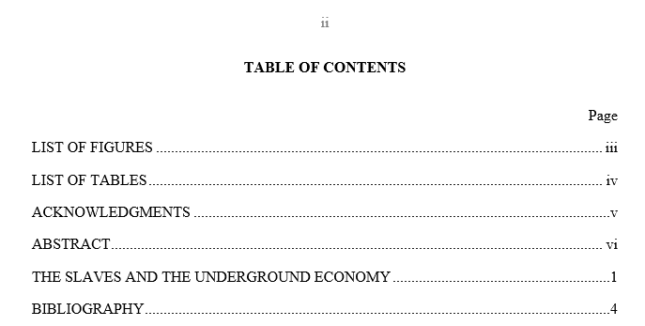
Figure 1 shows the TABLE OF CONTENTS with one chapter as the body of thesis.
Figure 1. Table of Contents with One Body of Thesis

Fine Arts/Non-Traditional Theses
Theses such as those including a book, essays, poems, screen plays, etc., have greater flexibility in formatting to accommodate disciplinary needs and appropriately convey information. This thesis style needs to abide by minimum formatting requirements for the following sections:
      - Title page
      - Table of contents
      - Abstract
      - Page margins and numbers
      - Font (unless it is necessary to meet the discipline, e.g. playright format)

Headings and Automated Table of Contents
This template has integrated the Graduate College’s required and recommended headings into the Styles Ribbon (Figure 2). The Styles Ribbon is located on the top right side of the Word document under the Home tab. You will use the Styles Ribbon to insert your headings throughout your thesis or dissertation in order to use the automatic Table of Contents feature (we call this dynamic content). To insert a heading into your document, click on the appropriate heading level in the styles ribbon. The styles have the respective bolding and alignment for each heading automatically built in, but you must manually write the heading title with the corresponding capitalization needed. Please read the information below regarding the styling of each heading.
The goal with the heading levels is consistency in terms of bold and italics, alignment, and capitalization. The Graduate College has requirements for the preliminary pages and chapter titles (also known as BODY OF THESIS in this template), while offering recommendations for additional heading levels. Differentiation needs to exist between heading levels. Heading levels are not on a different page from its text (at least 2 lines of body text accompany a heading level before the end of a page) which is already a feature of the template.
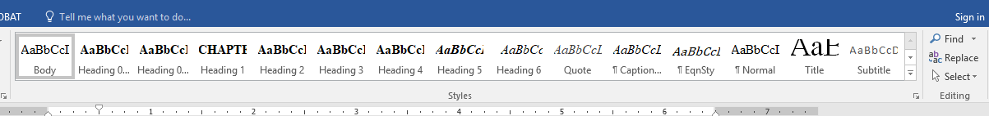
Figure 2. Screen Shot of the Styles Ribbon.

Level 0 Heading (Appears as LEVEL 0 HEADING)
Heading Level 0 is used for the headings in the preliminary pages (everything before the first BODY OF THESIS), including DEDICATION, TABLE OF CONTENTS, LIST OF FIGURES< LIST OF TABLES< NOMENCLATURE, ACKNOWLEDGEMENT, and ABSTRACT. Within the Styles Ribbon, there are two Heading Level 0 options: in Heading 0 (included in TOC) and Heading 0 (not in TOC). Heading 0 (not in TOC) is used for the Dedication (optional to include in your thesis/dissertation) and TABLE OF CONTENTS section headings, neither of which will appear in your TABLE OF CONTENTS. All other preliminary sections you choose to include will use the Heading 0 (included in ToC).

First Level Heading (Appears as BODY OF THESIS. FIRST LEVEL HEADING)
BODY OF THESIS headings or SECTION TITLES are called Heading 1 in the Styles Ribbon. To insert a new body of thesis, simply click on Heading 1. After clicking on Heading 1, write the title of your BODY OF THESIS/SECTION TITLE. The Graduate College requires each Heading Level 1 to be centered, all uppercase, and bolded. The template has the centered and bolded text options built in, but you must manually make your body of thesis/section title text all uppercase. Please reference INTRODUCTION TO THE THESIS/DISSERTATION TEMPLATE or USING THE STYLES RIBBON FOR HEADINGS as examples for how this heading should look.

Second Level Heading
Second level headings (Heading 2 in the Styles Ribbon) are recommended to be bolded, centered, and the first letter of each word capitalized, except single-syllable conjunctions and prepositions.

Third Level Heading
Third level headings (Heading 3 in the Styles Ribbon) are recommended to be bolded, left justified, and the first letter of each word capitalized except single-syllable conjunctions and prepositions. If the chapter title or heading is longer than one line, use single spacing between the lines of the title (this is built into the style).

Fourth level heading
Fourth level headings (Heading 4 in the Styles Ribbon) are recommended to be bold, indented, and only the first word is capitalized.

Fifth level headings
Fifth level headings (Heading 5 in Styles Ribbon) are recommended to be bold, italicized, indented, and only the first word is capitalized.

Sixth level heading
Sixth level headings (Heading 6 in the Styles Ribbon) are recommended to be italicized and indented and only have the first word capitalized. These deeper levels of headings do not necessarily need to be included in the Table of Contents; see “Changing Number of Levels Shown in the Table of Contents” for more information. The sixth level heading should also be inline if the fourth and fifth levels headings are in line with the text.

Body Style
Paragraphs of the body text are all indented (this is set in the “Body” Style from the Styles ribbon). Text is double spaced and indented. If you are moving your content from a different Word document into this template, paste your paragraphs as text only and confirm that the paragraph is styled as Body (not Normal) from within the Styles pane. Additionally, make sure to assign each of your headings a Style, accordingly (e.g., Heading 2, Heading 3, etc.).

Navigation Pane
It is recommended that you view your Navigation Pane when inserting your headings in order to do check if your headings are at the appropriate level and consistent styling is being applied. Click on your View tab, then select the box for Navigation Pane; it will appear on the left side of your document. For Mac users, you will need to click the bullet pointed list at the top of your Navigation Pane to see the headings, rather than the pages. The Navigation Pane shows you all of the headings you have successfully linked using the Styles Ribbon. Subsequently, you can see if you have accidentally linked text inappropriately as a heading, have a heading at the wrong level, have blank space linked as a heading, or to check the capitalization consistency in your headings. If you see an incorrectly linked heading, simply go to the incorrect location in your document, highlight it, and select the appropriate style.

Automatically Updating the Table of Contents
One of the benefits of creating your section headings with the Styles Ribbon is that it will connect your headings to an automatic TABLE OF CONTENTS. This means that you never need to keep track of what page your headings are on or editing your table of contents as heading sections move – the TABLE OF CONTENTS will be able to “read” which page your heading is on, then put the information in your TABLE OF CONTENTS. However, you must update your TABLE OF CONTENTS in order to see the most current version of it. Hover your cursor anywhere in your TABLE OF CONTENTS, right click, select Update Field, click Update Entire Table, then OK. You now see your most updated TABLE OF CONTENTS.

Changing Number of Levels Shown in the Table of Contents
The Graduate College requires you to have a minimum of one heading level (Headings 0 and 1) in your TABLE OF CONTENTS. To change how many levels are shown in your TABLE OF CONTENTS, go to the REFERENCES section, click the dropdown menu for TABLE OF CONTENTS and click Custom Table of Contents to open the editing screen. Change how many levels you would like to show using the “Show Levels:” option box (Figure 3).
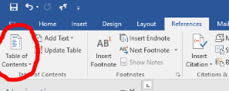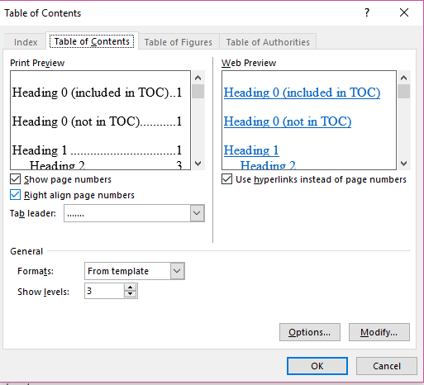
Figure 3. How to Change the Number of Heading Levels Shown in the Table of Contents
Choosing “2” would meaning Heading Level 1 and Heading Level 2 would show in the Table of Contents while Choosing “3” would mean Heading Level 3 would also appear in the Table of Contents.

Additional Information
The Graduate College does not require a LIST OF FIGURES or a LIST OF TABLES. This is called dynamic content. To update your LIST OF FIGURES and LIST OF TABLES in your thesis/dissertation. However, if you choose to include either list, you must include the other (Note: If you, for example, have a List of Figures, but no tables within your document, you do not have the List of Tables [and vice versa]). You cannot combine these lists into one list.
A consistent style should be used for all tables and figures. Table captions are located at the top of the table. Figure captions are located at the bottom of the figure. Captions longer than one line uses consistent line spacing and indentation. They can be captioned sequentially (Figure 1, 2, 3, 4, etc.) or utilize chapter numbering (Figure 1.1., 1.2., 1.3., 2.1., 2.2, etc.). You can style the caption (e.g., bolded vs. italics, sentence case vs. uppercase, alignment, etc.) however you would like, just be consistent.
The process for linking figures and tables to their respective lists is nearly identical (see Table 1 for steps on linking figures and tables). After you follow these steps, highlight the portion of the title that says “Figure X” or “Table X” – if the number is in an extra dark box, you have correctly linked your Figure or Table. This is called dynamic content. To update your LIST OF FIGURES and LIST OF TABLES, right click on the list and choose Update Field.
Table 1. Instructions for Linking Figures and Tables to the Respective Lists
Steps | Instructions
Step 1 | Paste or insert your figure or table into the document. Make sure it fits inside of your margins.
Step 2 | Highlight the entire figure or table. Right click on the highlighted item and select Insert Caption.
Step 3 | Next to “Options, Label:”, select either Figure or Table. If it is a Figure, make sure the “Position:” option selected says “Below Selected Item” and if it is a Table, make sure the “Position:” option selected says “Above Selected Item”.
Step 4 | Click on the “Numbering, Format:” option. If you would like to include both the chapter number and item number in the Figure or Table title (e.g., Figure 5.1), check the “Include Chapter Number” box and select which kind of separator you want. If you do not want to chapter number in the caption, make sure to deselect this box.
Step 5 | Returning to the original editing box, write your Figure or Table title and press OK when you are finished. Note: If you like to have a period and space after “Table 1”, make sure to manually write this in as you type your title.
Step 6 | You will now see your Figure or Table title below or above the item, respectively. You can style these headers (bolded, italicized, centered, left justified, etc.) however you like, just be consistent throughout your document. You can also edit your title by adding or removing text.
Step 7 | Some versions of Word will insert the Figure or Table title within a text box. It is recommended that you cut the inserted title from the text box, delete the text box, and past it onto the regular document.

If you have a table that continues onto a subsequent page, you need to start each new page with two rows of information. The first row says “Table X Continued”, and the second row is the Table headers. You can do this by either splitting the table (within Table Tools: Layout tab) or inserting two new rows into the table.
If you have a very long figure or table title, you can truncate it so only the main portion is included in the LIST OF FIGURES and LIST OF TABLES. Insert your title caption following the steps above.
Table 2. Instructions for Truncating Title Captions in the List of Figures and List of Tables
. Here is extra information that I don’t want to show up in my List of Tables.
Steps | Instructions
Step 1 | 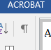  Turn on your show/hide feature. Put your cursor immediately following the information you want to appear in the List of Figures or List of Tables.
Step 2 | Insert a Continuous Break by going to the Layout section, clicking the dropdown arrow next to Breaks, and selecting Continuous Break.
Step 3 | Hold down the shift button and arrow over the inserted Continuous Break to highlight it. Make sure to ONLY highlight the Continuous Break.
Step 4 | Under the Font dropdown in the Home tab, select Font, and check the Hidden box (see Figure 1).
Step 5 | Turn off the show/hide feature. The Continuous Break will no longer be visible and the title caption will look normal and continuous.
Step 6 | Update the respective list to see the truncated version of your title.

Figure 4. Hiding Text from Figure and Table Captions in the List of Figures or Tables

ADDITIONAL BODY OF THESIS OR SECTION TITLE (AS NEEDED)
(IF USING THE SINGLE JOURNAL ARTICLE STYLE, IGNORE THIS SECTION)
For Journal Article Thesis (Single Chapter Only) works, delete this section. For Fine Arts/Non-Traditional Thesis Dissertation, including a second BODY OF THESIS is optional. If additional chapters are not necessary, follow Figure 1 for a possible TABLE OF CONTENTS.
If more BODIES OF THESIS are necessary, create more additional bodies accordingly. Subheaders are optional. If there are subheaders, the decision to list them in the TABLE OF CONTENTS is up to the student, major professor, and POS committee.
Figures 5 and 6 below illustrates how the TABLE OF CONTENTS would look like if there were more than one BODY OF THESIS (See Figure 1.)
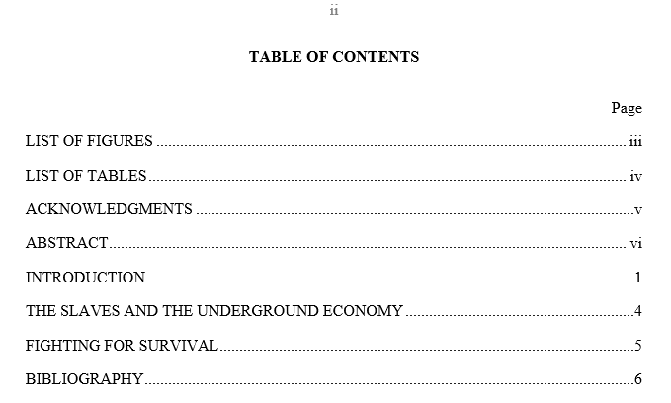
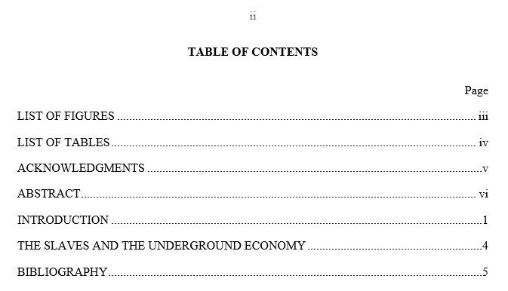
Figure 5. Table of Contents with Two Bodies of Thesis
Figure 6. Table of Contents with Three or More Bodies of Thesis

BIBLIOGRAPHY
[Insert references here, using a style appropriate to journals or articles in your field. Single space, double space between is recommended. Double spaced throughout is appropriate as well]
[Insert references here, using a style appropriate to journals or articles in your field. Single space, double space between is recommended. Double spaced throughout is appropriate as well]
[Insert references here, using a style appropriate to journals or articles in your field. Single space, double space between is recommended. Double spaced throughout is appropriate as well]
[Insert references here, using a style appropriate to journals or articles in your field. Single space, double space between is recommended. Double spaced throughout is appropriate as well]
[Insert references here, using a style appropriate to journals or articles in your field. Single space, double space between is recommended. Double spaced throughout is appropriate as well]
[Insert references here, using a style appropriate to journals or articles in your field. Single space, double space between is recommended. Double spaced throughout is appropriate as well]
[Insert references here, using a style appropriate to journals or articles in your field. Single space, double space between is recommended. Double spaced throughout is appropriate as well]

